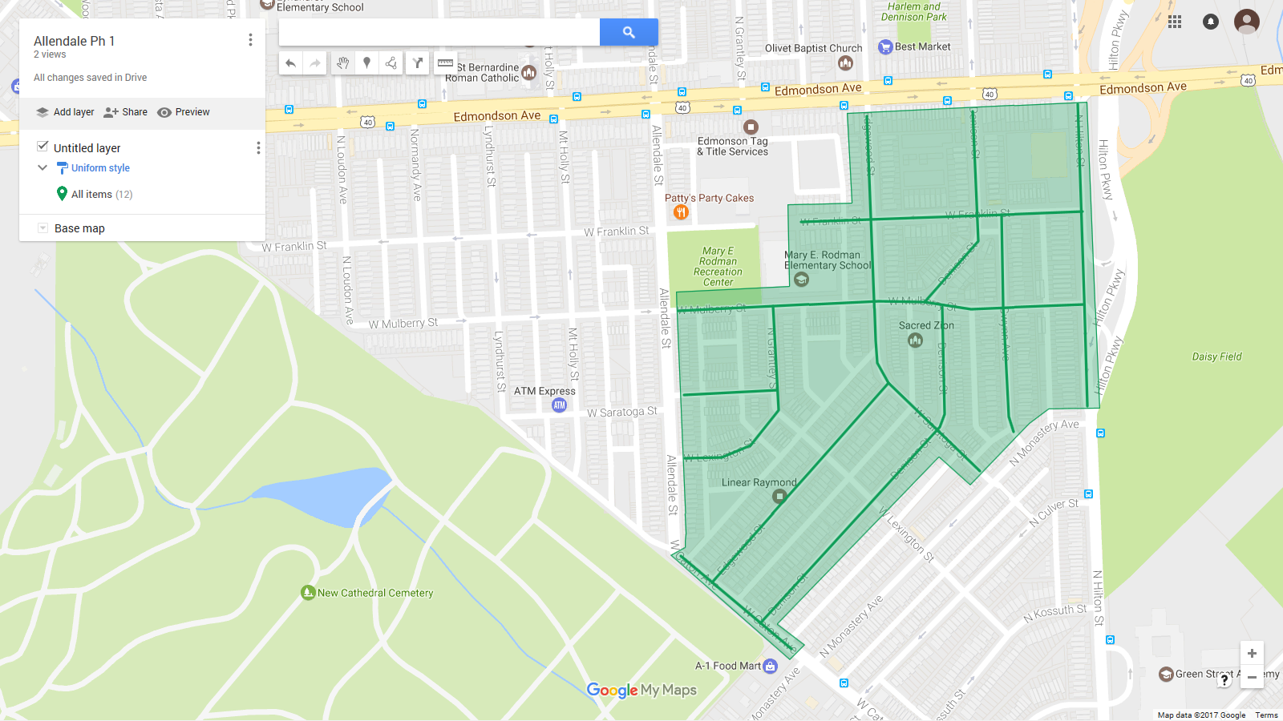

Figure 1: Allendale Phase 1 Operation Pipeline job shown shaded in green, with streets to be worked highlighted.