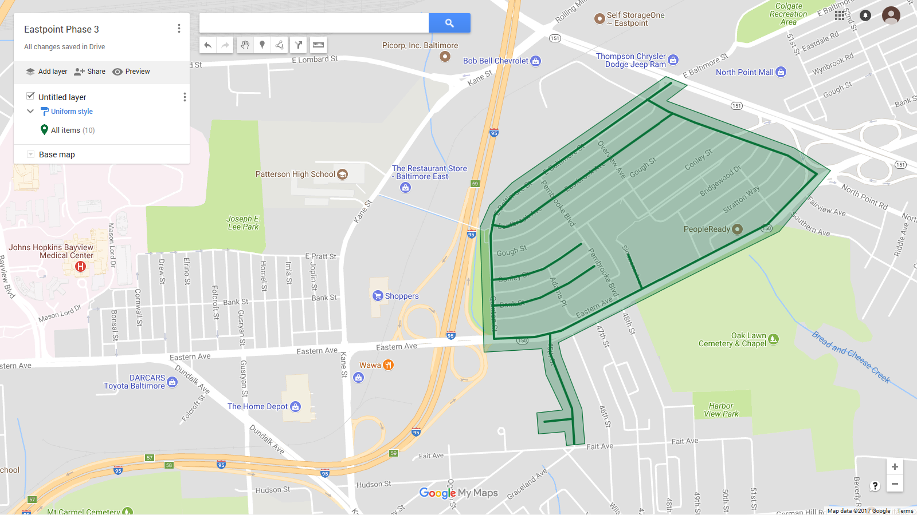

Figure 1: Eastpoint Phase 2 Operation Pipeline job shown shaded in green, with streets to be worked highlighted.