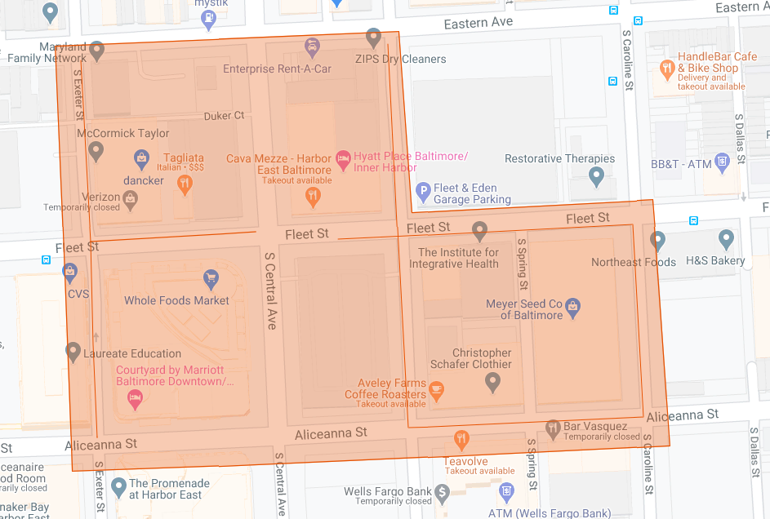

Figure 1: Fells Point Phase 1 Operation Pipeline job shown shaded in orange with the streets to be worked highlighted.