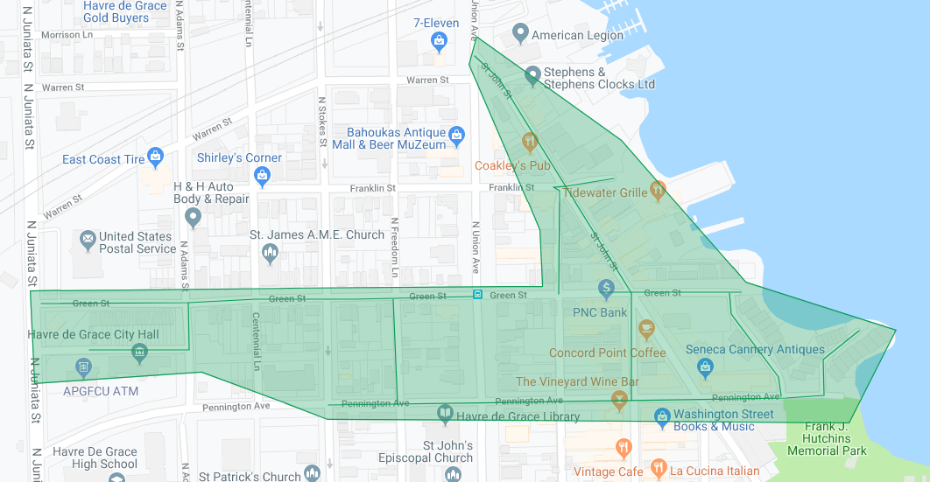

Figure 1: Havre de Grace Phase 5 Operation Pipeline job shown shaded in green with the streets to be worked highlighted.