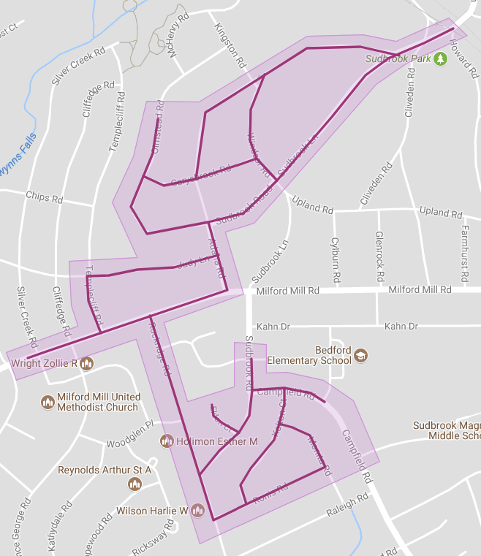

**Figure 1:** Sudbrook Park Ph 2 Operation Pipeline job shown shaded in purple with the streets to be worked highlighted.