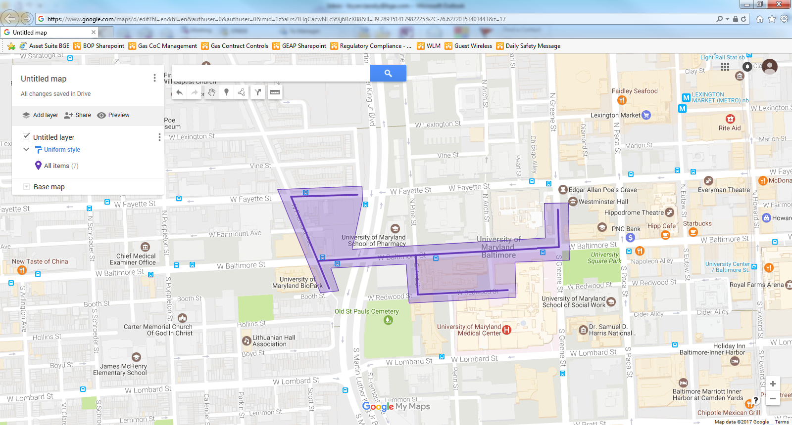

Figure 1: UMD Phase 2 Operation Pipeline job shown shaded in purple, with streets to be worked highlighted.